Accessing the event on Slido
- On your mobile, tablet or computer, go to slido.com
- If you prefer you can also use the Sli.do app, available from the iOS and Android app stores
- Enter the event code: #XXX - This code will be used throughout the Event for all presentations.
Submitting and viewing questions

- After logging into the event you’ll be presented with the delegates view. There is a box in the centre of the page for submitting questions.
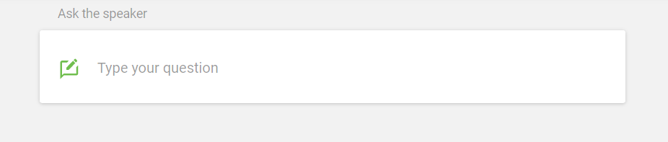

- Enter your question into the box, along with a name (you can leave this box blank if you prefer). Click send to submit your question. There is a character limit (shown in the bottom right).
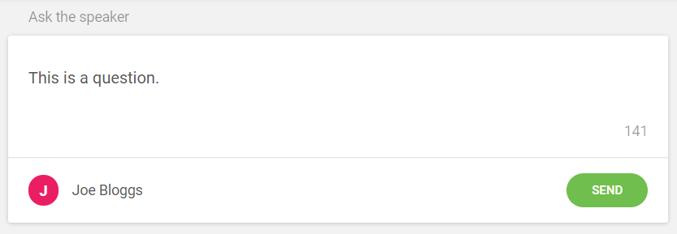
- Questions will appear below the box. You’ll see all questions submitted by delegates here.
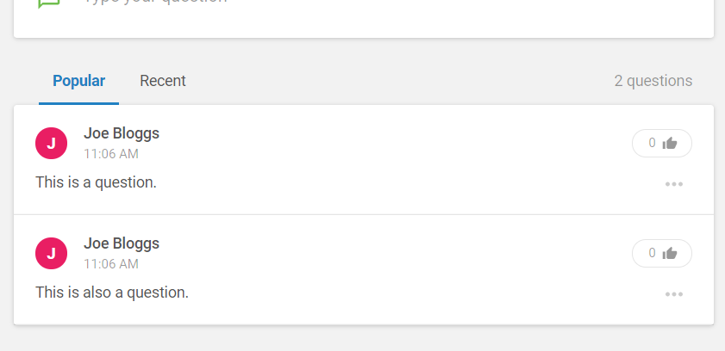
- In the “…” menu next to one of your submissions, you can Edit or Withdraw your question.
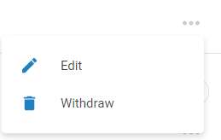
- The thumbs up button can be used to up-vote a question, which can be seen by all delegates and chairs/administrators of the event. Use this to indicate the questions you are most interested in hearing answered.

